QED Effects in Multi-TeV Scale Electron-Positron Collisions
Ryan Saelens | Dr. Philippe Piot | 03.26.2024

Abstract
When a beam of electrons collides with a beam of positrons – an antimatter electron—the distribution of the electrons gets disrupted due to the electromagnetic field of the opposing bunch, i.e., the positrons. In addition, the deflection of the particles in the field of the opposing bunch results in emission of electromagnetic radiation, known as beamstrahlung—when a charged particle slows down or gets redirected. Along with beamstrahlung, certain QED effects need to be considered regarding the disruption, collision, and production of electrons and positrons: quantum synchrotron; Breit-Wheeler process (BW); Multiphoton Breit-Wheeler process (MPBW); Bethe-Heitler process (BH); and the Landau-Libshitz process (LL). Note that the QED effects are not something that happens after the collision (not necessarily), but rather, they are conditions that the e+e- beams undergo as they approach each other, and hence get disrupted. Simulations of e+e- collisions and the QED effects they experience, such as quantum synchrotron and the MPBW process, can be obtained successfully using WarpX; the other QED effects are currently in development.

Introduction
A proposal has been made for an e+e- collider—the Advanced Linear International Collider, otherwise known as ALIC, with a center-of-mass (COM) energy of up to 30 TeV, and a luminosity of 10^38 cm^2 (which meets the luminosity goal), generating an event sample of roughly 30ab^-1 after running for only a few years [1]. This machine will be based on the advanced novel accelerator (ANA) concept, which provides advancements for accelerator technologies, using techniques based on wakefield generation; and in turn stronger, more efficient machines can be developed for use in high-energy physics [6]. Let us first consider the significance of colliding electrons with positorns; this will help to better appreciate the need for a collider such as ALIC.

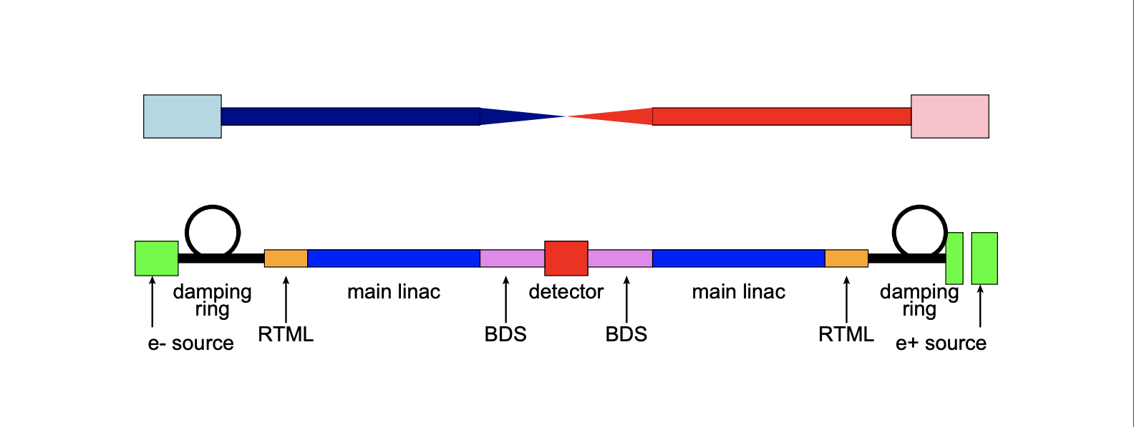
Colling Electrons and Positrons

A lepton, such as an electron, in comparison to a hadron (i.e., a proton, which is composed of smaller component-particles, such as quarks and gluons.), consists of no smaller particles; an electron is fundamental in Nature, and by extension so too is its antimatter particle–the position. When these particles are smashed together, the collision offers a great deal of energy—yet far less noise than that of a hadron collision; since the particles being smashed aren’t made of smaller particles. This is important to consider when searching through the collision debris for rare particles such as the Higgs Boson, or something even more controversial like a dark matter particle.
Consider the generalized figure above of an e+e- collider [5]. For an e+e- collider (like ALIC), we will not be sending just an individual electron to collide with an individual positron. We already know that when this event takes place, the result is simply a conversion into two high-energy photons. So instead we accelerate large bunches of electrons and positrons through their own damping-rings, towards each other; by the time they each reach their side of the main linac, they will be high-density beams that then get sent through a beam delivery system (BDS) to be finely focused before “colliding”, and ultimately the dector(s) convey any feedback.

Beamstrahlung
While this effect can be explained using E&M, it is an effect, nonetheless, that the electrons and positrons composing the beams, experience.When a particle emits electromagnetic radiation, a charged particle in motion can be slowed down and deflected, due to this radiation–this effect is known as beamstrahlung. From this we know then the beam of electrons will exert a force on itself as well as on the beam of positrons, and the positrons will exert a force on themselves and also on the electrons.

Beam-Beam (QED) Effects to Consider
The e+e- beams can experience the following list of QED effects [2]:
- Quantum Synchrotron
- The Multiphoton (Non-Linear) Breit-Wheeler Process
- The Linear Breit-Wheeler Process
- The Bethe-Heitler Process
- The Landau-Lifshitz Process
Below are the Feynman diagrams [3] pertaining to the QED effects that result in e+e- pair production (i.e., not including quantum synchrotron).

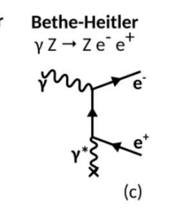
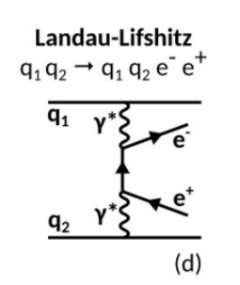
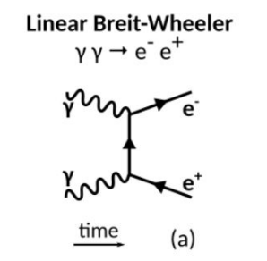
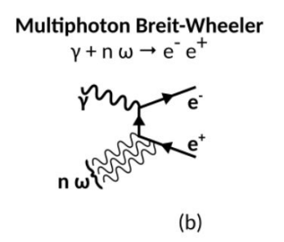

Quantum Synchrotron
An accelerated particle, such as an electron or a positron, can emit photons rather discreetly, and in turn, these discrete photons can have an effect on other neighboring charged particles. This QED effect is known as quantum synchrotron. For example, the e+e- beams can experience this effect while being sent through their appropriate BDS. This can happen outside of the BDS. As the beams inch closer to each other, they can experience quantum synchrotron, emitting photons that may interact with other charged particles so quickly, and while in the midst of the collision, such that we will need to fine-tune our measuring devices before being able to properly analyze what is happening exactly.

Nonlinear Breit-Wheeler Process
As a result of quantum synchrotron, for example, an effect known as the Nonlinear Breit-Wheeler process (NLBW) can arise; this effect is also known as the Multiphoton Breit-Wheeler process. It takes place when a photon decays into an e+e- pair within the space-charge fields of the beams, i.e. the area in which the charge of the beams extends out to [2]. As we will see this isn’t the only QED process that is capable of e+e- pair production.

Linear Breit-Wheeler process
While the NLBW process addresses how a high-energy photon can decay into an e+e- pair, another process known as the linear Breit-Wheeler process (LBW), explains how two high-energy photons annihilate, which in turn creates an e+e- pair. Seeing how we have many electrons and positrons, and we know that discrete photons can be emitted from each of them as they accelerate, we have a high probability of e+e- pairs being created since there is a high possibility of high-energy photons being created on from both electrons and positrons, and therefore those photons will be ready to annihilate each other, giving more electrons and positrons.

Bethe-Heitler Pair Production
The NLBW isn’t the only QED process that deals with the decaying of high-energy photons into e+e- pairs. The Bethe-Heitler pair production (BHPP) states that a high-energy photon decays into an e+e- pair while accelerating by another, individually charged particle. So a photon passing by an electron (negatively-charged) can experience this effect, as well as a photon that passes by a positron (positively-charged). Again, figuring that we have high-density beams of each, things can get extremely messy as they get closer and closer to colliding.

Landay Lifschitz
Arguably, the most interesting QED process currently being studied is called the Landau-Lifshitz (LL) process. Much like the BHPP process, it considers what happens when a charged particle is interacted with. Where the BHPP process deals with a photon passing by a charged particle to produce an e+e- pair, the LL process states that a charged particle can emit an e+e- pair as it accelerates past another charged particle. Essentially, this process deals with a charged particle having an effect on another charged particle. So this means that each of the electrons in the electron-beam have the potential to affect the positrons in the positron-beam and the same is true the other way around. So, many e+e- pairs are being produced from this process (not to mention the amount that can be potentially created from the other mentioned processes) as the e+e- beams approach one another.

Simulating Beam-Beam Effects Using WarpX
As of March, 2024, WarpX is capable of simulating the effects of quantum synchrotron as well as the MPBW process. The implementation of the LBW process is almost complete; the BHPP and LL processes are currently planned to be implemented over the following few months [2].

Below are multiple simulations of 2D flat beams using WarpX [7]:

Here we have a collision simulation without QED effects disrupting the two beams. Notice how nicely they transfer after passing by each other:


This is strictly due to the fact that no QED effects are present to disrupt the event.

Next, we have a few simulations of the beams colliding, this time with the implication of the QED effects explained above. These give a better idea of what will happen in reality. On the left, we have the scattering of the drive-beams; in the middle we have the production of photons as the beams collide; on the right, we have the production of e+e- pairs, as the beams collide:




It’s important to remember that we have multiple QED effects that result in the production of e+e- pairs—yet notice how the production of photons in the middle simulation closely follows the simulation on the left—yet it is still somewhat denser; and also that it is nearly twice as dense as the simulation on the right, i.e. photon production seems greater than e+e- pair production (based on these simulations).

e+e- Collider up to 30TeV
We need to already be thinking about the possible benefits that can be obtained through the implementation of accelerators (colliders) with COM energies of at least 10TeV. Let us go back to the dark matter particle problem for a moment. Since the dark matter particle is composed of no ordinary matter, it weakly couples to known matter. It is believed [1] that the dark matter particle manifests as a light particle and doesn’t get detected due to its composition and interaction(s) with ordinary matter. This seems like a problem relating to the QED process of quantum synchrotron. WarpX can address and simulate this QED process, so hopefully it can lead to the ruling-out of certain discrete photons as the possibility of being dark matter particle candidates. Interestingly enough, this problem of electroweak symmetry breaking, along with the spectrum of fermion masses, and the CP violations, can really only be explained by short-distance interactions such as those interactions made by electrons and positrons [1].
The Advanced Linear International Collider (ALIC) is proposed to be built by 2040. In reality, this is not very far away. During this time, due to the implementation of ANAs to advance collider technology, we can look forward to seeing advancements in the fields of biology and medicine [6] while we wait for advancements in high-energy physics. This makes sense intuitively due to the important use of electrons in both fields. With that said it is a lepton collider [1] that must be relied on in order to explore the full range of particles that sit within the region of 10 TeV and above. From searching for particles we can then move on to confronting the deeper issues of the universe.

Conclusion
It seems rather reasonable to assume that WarpX will have the full list of QED effects above, implemented by the time ALIC is ready to operate—in fact ALIC seems almost reliant on WarpX being able to properly simulate the QED effects that e+e- beams experience as they collide with extremely high-energy output. It can also be the case that by creating ALIC we can then run simulations using WarpX at the new COM energy output, which can in turn help us better understand the certain properties that affect our e+e- beams.

References
[1] ALEGRO Collaboration. Towards an Advanced Linear International Collider. (2019). https://arxiv.org/pdf/1901.10370.pdf
[2] R. Lehe, J.L. Vay. Plans for WarpX. (2024). https://indico.slac.stanford.edu/event/8597/contributions/8188/attachments/3935/10601/2024_beam_beam.pdf
[3] A. Formenti. First results of beam-beam simulations with WarpX. (2024). https://indico.slac.stanford.edu/event/8597/contributions/8191/attachments/3936/10602/beambeammeetingslac.pdf
[4] W. Herr, T. Pieloni. Beam-Beam Effects. (2014). https://cds.cern.ch/record/1982430/files/431-459%20Herr.pdf
[5] D. Schulte. Beam-Beam Effects in Linear Colliders. (2017). https://indico.cern.ch/event/457349/attachments/1175828/1699810/Beam-beam2.pdf
[6] B. Cros, P. Muggli. ALEGRO input for the 2020 update of the European Strategy for Particle Physics: comprehensive overview. (2020). https://indico.cern.ch/event/765096/contributions/3295514/attachments/1785110/2906015/2018_ALEGRO_ESPP.pdf
[7] S. Gessner. SLAC. Beam-Beam Meeting at SLAC. (2024). https://docs.google.com/presentation/d/120J9lWAcpK4Hsj0jktCw61iZGLTTqrtuUPDaGtZRvE8/edit#slide=id.p1

